The list of international research projects that are performed at OSENU as of 2023

«Developing Optimal and Open Research Support for the Black Sea — DOORS»,
Grant Agreement No. 101000518 (01.06.2021 – 31.05.2025)
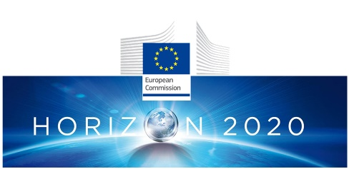

Programme: Horizon 2020, H2020-EU.3.2.3.3

The purpose and tasks of the project:
1. To create a coordinated set of methodologies for collecting and analyzing data on the state (physical, chemical, biological) of the Black Sea for coordinated regional access and use of this information.
2. To combine interdisciplinary scientific knowledge to eliminate the impact of anthropogenic load and climate change for effective policy implementation in the Black Sea.
3. Implement the potential of ecosystem services and Blue Growth sectors and provide support to entrepreneurship.
4. Raise public awareness of the rational use of the Black Sea environment and understanding of the value of ecosystem services in the Black Sea.

Expected results:
Implement the Strategic Research and Innovation Program for the Black Sea (Strategic Research and Innovation Agenda for the Black Sea (SRIA))

Project coordinator: The National Research-Development Institute for Marine Geology and Geoecology “GeoEcoMar” (GEOECOMAR), Bucharest, Romania.

Partnership:
- The Institute of Oceanology at the Bulgarian Academy of Sciences, Bulgaria
- GeoMarine, Bulgaria
- Burgas Free University, Bulgaria
- The University of Stirling, UK
- National Oceonography Centre, UK
- Plymouth Marine Laboratory, UK
- Michael Rea Media, UK
- Hellenic Centre for Marine Research, Greece
- Αthena Research and Innovation Centre, Athens, Greece
- Kantor Management Consultants, Greece
- GIS and RS Consulting Center GeoGraphic, Georgia
- University College Cork, Ireland
- The Polytechnic University of Catalonia, Spain
- SOCIB, Spain
- CNR-ISMAR, Italy
- National Institute of Geophysics and Volcanology, Italy
- Tiraspol State University, Moldova
- Deltares, the Netherlands
- Helmholtz Center Hereon, Germany
- Brockmann Consult, Germany
- Grigore Antipa National Marine Research and Development Institute, Romania
- Mare Nostrum, Romania
- Middle East Technical University, Turkey
- Dokuz Eylül University, Turkey
- Karadeniz Technical University, Turkey
- National Academy of Sciences of Ukraine
- Odessa State Environmental University, Ukraine
- Pôle Mer Méditerranée, France
- Ifremer, France

Project website: https://www.doorsblacksea.eu/

«Restoration of the Danube River Basin Waters for Ecosystem and People from Mountains to Coast», Grant Agreement № 101093985 (01.03.2023 - 31.12.2027)

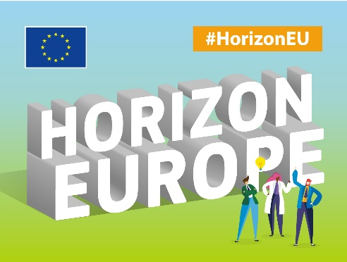

Program: Horizon Europe, HORIZON-MISS-2021-OCEAN-02-02 - Danube River Basin Lighthouse – Restoration of Fresh and Transitional Water Ecosystems

The overall aim of DANUBE4all is the development of a comprehensive Restoration Action Plan for the Danube river basin lighthouse developed in an unprecedented co-creation process with stakeholders, integrating citizens’ interests to support the Mission “Restore our ocean and waters by 2030”.

Expected results:
- Collected comprehensive base of scientific information, including data and understanding of the processes in the Danube basin and watercourse for restoration and obtaining the status of "free-flowing river" by the river ecosystem.
- Demonstration events were held, and business programs were implemented at three sites - in the Upper, Middle and Delta of the Danube.
- Organized activities aimed at mobilizing citizens to manage the river and stimulate economic benefits.
- The results, knowledge and tools obtained in the Danube Basin were submitted to the five Associated Regions to build capacity and develop replication roadmaps for restoration actions.

Project coordinator: University of Natural Resources and Life Sciences, Vienna, Austria
Partnership:
- Zentrum Fur Soziale Innovation GmbH, Austria
- Via Donau Osterreichische Wasserstrassen Gesellschaft MBH, Austria
- DANUBEPARKS - Danube River Network of Protected Area - Das Netzwerk Der Donauschutzgebiete, Austria
- Institut po Bioraznoobrazie i Ekosistemni Izsledvaniya Balgarska Akademiya na Naukite, Bulgaria
- Ruder Boskovic Institute, Croatia
- Ecologic Institut gemeinnützige GmbH, Germany
- Forschungsverbund Berlin EV, Germany
- WWF Vilag Termeszeti Alap Magyarorszag Alapitvany, Hungary
- Budapesti Muszaki Es Gazdasagtudomanyi Egyetem, Hungary
- University College Cork - National University of Ireland, Cork, Ireland
- Consiglio Nazionale Delle Ricerche, Italy
- De Vries Sandra, Netherlands
- Stichting Wereld Vismigratie, Netherlands
- Stichting Deltares, Netherlands
- Institutul National De Cercetare-Dezvoltare Pentru Geologie Si Geoecologie Marina - GEOECOMAR, Romania
- Institutul National De Cercetare-Dezvoltare Delta Dunarii, Romania
- Asociatia WWF Romania, Romania
- Civitta Strategy & Consulting SA, Romania
- Institut za Multidisciplinarna Istrazivanja, Serbia
- Global Water Partnership Central and Eastern Europe, Slovakia
- Vyskumny Ustav Vodneho Hospodarstva, Slovakia
- Univerza v Ljubljani, Slovenia
- Odessa State Environmental University, Ukraine

Project websites: https://cordis.europa.eu/project/id/101093985, https://danubeparks.org/projects/danube4all-2023-2027

«DANUBIUS Implementation Phase Project - DANUBIUS-IP», Grant Agreement № 101079778 (01.10.2022 - 30.09.2025)

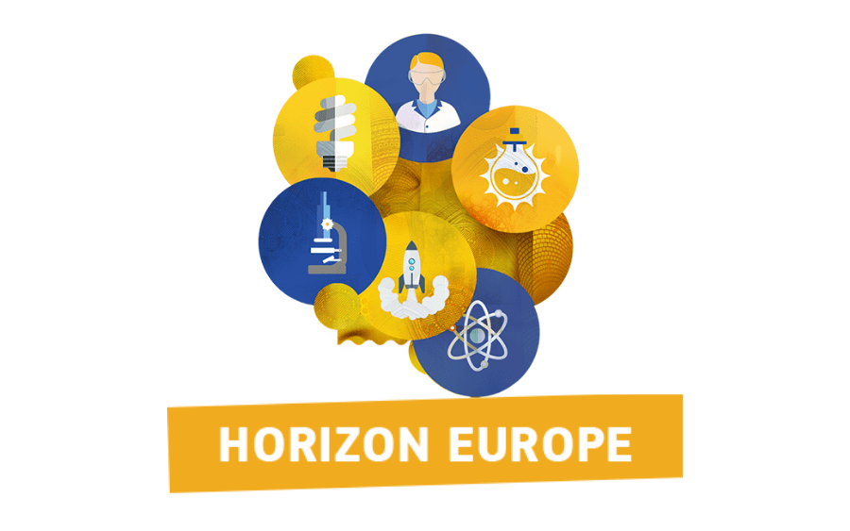

Program: Horizon Europe, HORIZON-INFRA-2021-DEV-02-02

The purpose and tasks of the project:
DANUBIUS-IP is a coordination and facilitation project to support the ongoing development of "The international center for advanced studies on river-sea systems" (DANUBIUS-RI) - an ecological research infrastructure connecting rivers and seas - at the stage of exploitation.
The aim of the project is to ensure the successful launch of DANUBIUS-ERIC and enable DANUBIUS-RI to move into the operational phase.

The project offers 7 work packages, which together should:
• develop a new RI management structure during the transition to DANUBIUS-ERIC;
• implement the Science and Innovation Agenda with the support of flexible scientific services with quality assurance;
• demonstrate the value of RI through examples of the unique services that RI can offer to end users across Europe and internationally;
• to expand the DANUBIUS-RI community and increase its position in European and international environmental RI;
• ensure broad awareness of DANUBIUS-RI's potential to have significant social and economic impact.

Expected results:
- Ensure the successful launch of DANUBIUS-ERIC by effectively transitioning from the current management structure to a DANUBIUS-ERIC specific one.
- Developing and strengthening the capacity of DANUBIUS-RI by connecting RI to major relevant European initiatives (such as EOSC), successfully implementing FAIR and open data policies and enabling full connectivity to the virtual world of specific DANUBIUS-RI services.

Project coordinator: The National Research-Development Institute for Marine Geology and Geoecology (GEOECOMAR), Bucharest, Romania.

Partnership:
- Wasserkluster Lunz Biologische Station GmbH, Austria
- Bulgarian Academy of Sciences, Bulgaria
- Ustav Vyzkumu Globalni Zmeny AV CR VVI, Czechia
- Universite De Lorraine, France
- Bundesanstalt Fuer Gewaesserkunde, Germany
- Bundesanstalt Fur Wasserbau, Germany
- Helmholtz-Zentrum HEREON, Germany
- Hellenic Centre for Marine Research, Greece
- Dimokritio Panepistimio Thrakis, Greece
- Szechenyi Istvan University, Hungary
- University College Cork - National University of Ireland, Cork, Ireland
- Consiglio Nazionale Delle Ricerche, Italy
- Corila - Consorzio Per Il Coordinamento Delle Ricerche Inerenti Al Sistema Lagunare Di Venezia, Italy
- European Multidisciplinary Seafloorand Water Column Observatory - European Research Infrastructure Consortium (EMSO ERIC), Italy
- Integrated Carbon Observation System European Research Infrastructure Consortium, Finland
- Institutul De Chimie Academia De Stiinte A Moldovei, Moldova
- Stichting Deltares, Netherlands
- Universitat Politecnica De Catalunya, Spain
- Autoridad Portuaria De Sevilla, Spain
- Stichting Ihe Delft Institute for Water Education, Netherlands
- National Institute for Research and Development for Biological Sciences, Romania
- The University of Birmingham, United Kingdom
- United Kingdom Research and Innovation, United Kingdom
- Plymouth Marine Laboratory Limited, United Kingdom
- Odessa State Environmental University, Ukraine

Project web-site: https://www.danubius-ri.eu/

